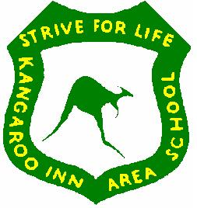  KANGAROO INN AREA SCHOOL POLICY | BUS  Ratified by KIAS Governing Council  May 2025

All details relating to the operation of school buses is contained in the DFE School Transport Policy, Jan. 2024.

Nearly all of our students are transported to and from school by bus. There are five runs in total:
- Beachport
- Robe
- Northern United / Greenways
- Furner
- Hatherleigh (school van)

The fleet is made up of large and small buses. Drivers must be properly licensed, have DFE approval to drive a school bus and follow DFE regulations as per the DFE School Transport Policy.

The principal acts as the Bus Manager in the school and any questions/ requests should be directed to that person.

Buses leave school immediately after school closure, so students cannot be detained after school.

All students enrolled at the school and living 5km or more from the school, can travel on one of the buses which serve the school. Schedules for each of the runs are available from the drivers or the school. Any concerns regarding buses should be directed to the Principal in the first instance. The DFE School Transport policy includes further information about eligibility.

Children attending the Preschool may use the buses. Parents are asked to check with the school when transport is required. All preschool students are required to use a car seat (school or family supplied).

Any bus issues regarding student behaviour need to be reported to the Principal or delegate.

The school requires consent from parents for a child to travel on other buses. No student will be allowed on a bus without parent consent. If the bus is to capacity, the request can be denied.

Being safety-conscious on the bus is very important.

Therefore:

- Parents / students are required to sign a form on enrolment to acknowledge their commitment to safe bus practices and drop-off / pick up information
- Students must wear seatbelts
- Students will sit in the seat allocated to them by the driver and not move from their seat for the duration of the bus journey
- Students will behave in a considerate and responsible manner at all times, will not use offensive language, will not throw things around the bus or otherwise distract the driver or other students, will follow reasonable instruction from the driver. The Student Wellbeing policy and Code of Conduct applies to all students travelling on school buses.
- Students / families will be required to reimburse the school for any damage they cause to buses
- For legal and safety reasons, no part of a student’s body will be outside the bus while it is in motion or stationery
- If behaviour issues occur and it is unsafe for the bus to continue, the driver contacts the principal or delegate and waits until the issue is resolved

Students unable to meet the required standards of behaviour may have the privilege of travelling on the bus withdrawn.

