|  |  |
| --- | --- |
| **KANGAROO INN AREA SCHOOL**  **Policy** | **Student Wellbeing Policy**  Updated - September 2023  Ratified by Governing Council –  Ratified by SRC -  Review 2025 |



***Background***

***Kangaroo Inn Area School*** *has utilised a proactive behaviour management process for several years with a focus on wellbeing underpinning positive behaviour. This year we worked to update our values to reflect our current cohort of students, staff and families. A new poster was created and the values were launched in term 2, 2023.*

*The school values are based on the belief that our learners ‘Strive for Life.’ They incorporate the values as our beliefs about ourselves as learners and community members and the learning assets as the way we learn. The students, staff and community contributed to the values and to choosing the appropriate learning assets from Kath Murdoch’s Inquiry process.*

*All behaviour and actions at our school are related back to the values and learning assets.*

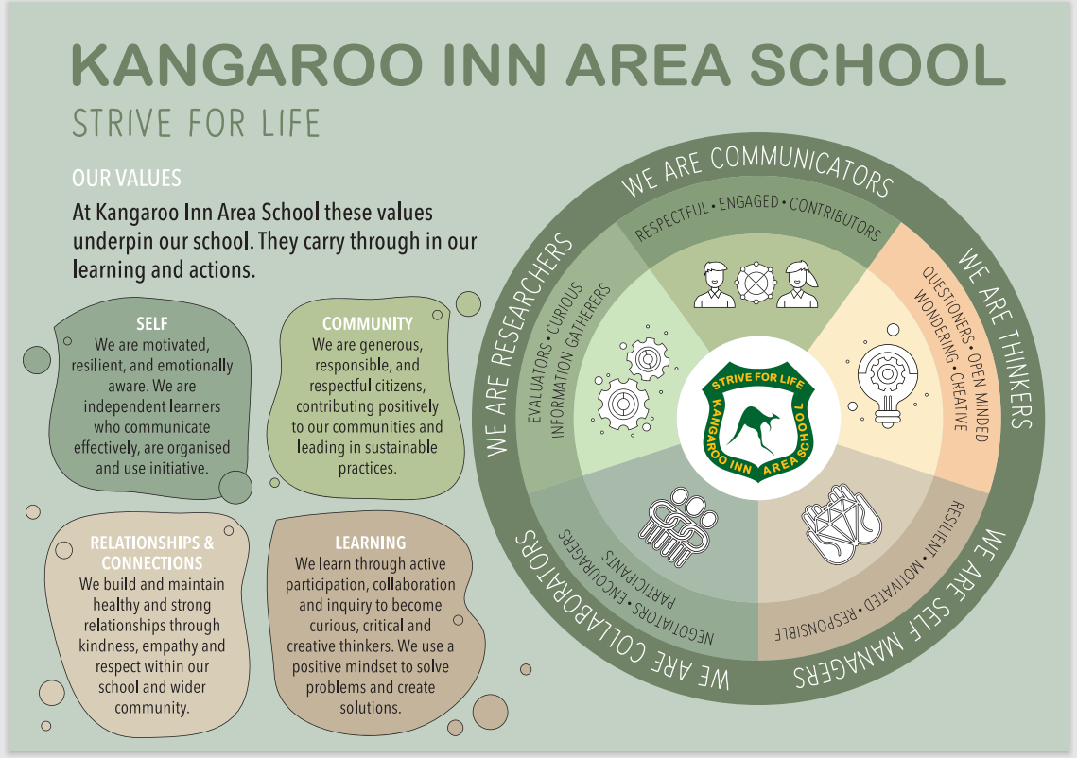

KIAS is a safe, supportive environment where encouraged to try new things, take risks and everyone is encouraged to try new things, t.

***Creating a successful learning environment***

***In building an engaging and successful learning environment we focus on our values***

***This occurs through***

* *Building staff knowledge and understanding of social and emotional learning- Resilience Project*
* *Classroom programs including the*
  + *Child Protection Curriculum*
  + *Social skills programs eg Play is the Way / Resilience Project / 4 R program ( Resilience, Rights and Respectful Relationships) – Vic Ed Dept / Zones of Regulation / Interoception*
  + *Learning to Learn program at the beginning of each year*
* *Student Voice – involvement in policy development and implementation, acknowledgement and feedback*
* *Pre-empting and resolving individual student behaviour concerns utilising the principals of Restorative Justice and reflective practices*
* *Public acknowledgment of embedding KIAS values through assemblies, awards, in class and in the newsletter*

|  |
| --- |
| ***The KIAS Student Wellbeing procedure is based on 3 levels of intervention -*** |

1. ***Reflection process***
2. ***Repair and Restitution***
3. ***Removal / Re-entry process***

***The final level involves External Suspension. See flowchart below for more detailed information***

***PRIMARY FOCUS***

***Play is the Way (PITW) Practices are currently used in the primary classes to support this process.***

***PITW - Reflective language***

We believe that the language we use, when correcting children on their behaviour, is key to creating opportunities for students to accept responsibility for their actions, make correct choices and develop resilience. This language is firmly embedded throughout our school.

* *“Right thing or wrong thing to do?”*
* *“Strong decision or weak moment decision?”*
* *“Feelings or thinking in charge?”*
* *“Am I trying to hurt you or help you?”*
* *“Are you running away from the problem or dealing with it?”*
* *“Being your own boss or asking me to be the boss?”*

***PITW - Code switching – “Are You Ready?”***

*This “Play is the Way” strategy has a clear focus on teaching students the importance of “code switching” and setting clear goals.*

*1. Students set a personal goal for the day.  
2. Discuss goal with the class*

*Student: “I’m ready to ….(states goal)”.*

*3. Students know that when they enter the classroom there is an expectation that they are ready to pursue their goal, to switch onto learning.  
4. Throughout the day the teacher will ask students to restate their goals.  
5. The class respond if the student is working to achieve the goal.*

***PITW - No rewards or punishment policy***

*We will be working with students to develop self-motivated learners. We believe using rewards and punishments to manipulate students’ behaviour is counterproductive. It takes talent, effort and patience to help students develop the skill of self-control and the commitment to manage their own behaviour.  Instead of using rewards, praise and punishments we need to teach children to reflect upon their actions and to learn more about themselves.*

***SECONDARY FOCUS***

*Secondary behaviour is guided by the KIAS Values and the Restorative Justice practices (Bill Hansberry). The Repair and Restitution process is based on this.*

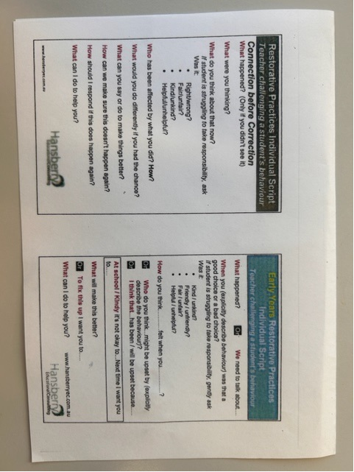

*** KANGAROO INN AREA SCHOOL***

***Student Wellbeing Process – Flowchart***

|  |  |
| --- | --- |
| ***REFLECTION PROCESS*** | |
| **Classroom / Yard Management**  *Management by home group/class/yard duty teacher based on PITW Self Control Checklist using Reflective Language. Yard duty teacher to liaise with class teacher / management.* | Class / home group teachers document and monitor |
| **Time Out - buddy class**  *Sent to buddy classroom for negotiated period of time* |
| **Time Out - yard jobs**  *Complete community based jobs eg rubbish pickup, weeding vegie garden in negotiation with Yard Duty teacher* |
| ***REPAIR AND RESTITUTION PROCESS*** | |
| **Investigate and Document Behaviour on Repair and Restitution Record where behaviour includes violence, bullying, harassment**  *Completed in negotiation with combination of Student / Class Teacher / Management team, after investigation.*  *In the ‘Making it Right’ section of the* ***Repair and Restitution Record*** *the act can be towards the aggrieved person, or if this is inappropriate,**community based tasks will replace it.*  *Copy to Prin. /Coord.*  Parents to sign ***Repair and Restitution Record.*** | Repair and Restitution Record / EMS |
| ***REMOVAL / RE-ENTRY PROCESS*** | |
| **Internal Placement**  *Management to administer and determine in individual cases*  *Class give student feedback on the* ***weak*** *decisions made by the student and how they can support the student to make* ***stronger*** *decisions*  *Removal from all classes and breaks for 1-5days (breaks at alternate times)*  *Communication with parents* ***will*** *occur via meeting or phone call where possible*  *Re-entry negotiated through management member responsible using Student Behaviour Contract and Reactive Strategies Chart if req.*  *Student names recorded in day book and details of behaviour recorded on EMS* | DFE Student File / EMS  Student Behaviour Contract  Reactive Strategies Chart |
| ***FINAL LEVEL*** | |
| **Suspension, Exclusion, Expulsion**  *Student’s behaviour is no longer self regulated and respectful*  *Formal DFE procedures will be followed ( See - Suspension, Exclusion and Expulsion of Students Procedure – DFE – 2024)*  *Process managed by Principal or Delegate* | DFE  Student File / EMS |

***We all need to protect the rights of teachers to teach, and students to learn***

***KANGAROO INN AREA SCHOOL – Student Wellbeing Process***

***Repair and Restitution Record - Primary / Secondary***

**To be completed with student after incident of bullying, violence, harassment by teacher / management**

|  |  |  |  |  |
| --- | --- | --- | --- | --- |
| **Name** | | | **Yr.** | **Date** |
| **What happened?** |  | | | |
| **What were you thinking ?** |  | | | |
| **What do you think about that now?**  If a student is struggling to take responsibility, ask was it  - right or wrong  - fair / unfair  - Kind / unkind  - Helpful / unhelpful |  | | | |
| **Who has been affected by what you did? How?** |  | | | |
| **What would you do differently if you had the chance?** |  | | | |
| **Making it right?**  What can you say or do to make things better? Eg apology, perform task requiring physical activity in break time eg rubbish pickup / yard jobs |  | | | |
| **How can we make sure this doesn’t happen again?** |  | | | |
| **How should I respond if this happens again?** |  | | | |
| **What can I do to help you?** |  | | | |
| **Staff comment**  sign / date | | | | |
| **Student signature**  **Date** | | **Parent signature**  **Date** | | |

***Please copy for Prin / file before original is sent home.***

***KANGAROO INN AREA SCHOOL – Student Wellbeing Process***

***Student Behaviour Contract - Primary / Secondary***

**To be completed with student after suspension due to bullying, violence, harassment by teacher / management**

|  |  |  |
| --- | --- | --- |
| **Name** | **Yr.** | **Date** |

|  |  |  |
| --- | --- | --- |
| **Break time support** | **Class Support** | **Outside support** |
|  |  |  |

|  |  |
| --- | --- |
| **SCHOOL EXPECTATIONS** based on KIAS Values | |
| **Achieving** | **Working on** |
|  |  |

**I ________________________________________________make a commitment to self regulate my actions so other students feel safe and do my best to achieve full participation as a KIAS student.**

|  |  |  |
| --- | --- | --- |
| **Student** | **Parent** | **School staff** |
|  |  |  |

Copy to student file / parent / student

***KANGAROO INN AREA SCHOOL – Student Wellbeing Process***

***Reactive Strategies Chart - Primary / Secondary***

|  |  |  |
| --- | --- | --- |
| **Name** | **Yr.** | **Date** |

|  |  |  |  |  |  |
| --- | --- | --- | --- | --- | --- |
| 1. ***Feeling good*** | ***Student Signals*** | ***Triggers / Challenges*** | ***What student can do*** | ***What staff can do*** | ***Goal*** |
|  |  |  |  |  |
| 1. ***Watch Out (Triggers)*** | ***Student Signals*** | ***Triggers / Challenges*** | ***What student can do*** | ***What staff can do*** | ***Goal*** |
|  |  |  |  |  |
| 1. ***Help***   ***(crisis)*** | ***Student Signals*** | ***Triggers / Challenges*** | ***What student can do*** | ***What staff can do*** | ***Goal*** |
|  |  |  |  |  |
| ***4. Breathe***  ***(calming)*** | ***Student Signals*** | ***Triggers / Challenges*** | ***What student can do*** | ***What staff can do*** | ***Goal*** |
|  |  |  |  |  |
| ***5. Lets Talk (recovery)*** | ***Student Signals*** | ***Triggers / Challenges*** | ***What student can do*** | ***What staff can do*** | ***Goal*** |
|  |  |  |  |  |

**these strategies? What was the outcome?**

**What cultural factors might be playing a role in this situation? Have there been any changes in the child’s life or in the school?**

**What might you do next? Talk to a colleague? Talk with the child’s parent or carer? Use child and family strengths to help you think of strategies?**

**What more information do I need about this child? Where could I get more information?**