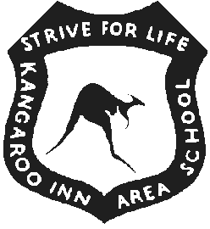  KANGAROO INN AREA SCHOOL  Policy | GRIEVANCES - PARENTS / CAREGIVERS & STUDENTS  April 2025

The parents/caregivers and teachers of students at Kangaroo Inn Area School enjoy productive and harmonious relationships, which enable us to work as effective partners for the good of the students. From time to time, however, points of disagreement or misunderstandings may arise.

Issues or misunderstandings need to be rectified quickly and sensitively, so that the important task of getting on with the education of our students in a cooperative manner can proceed as normal. We acknowledge the importance of fostering positive relationships between school and families.

The following Grievance Processes are published so that parents have a clear understanding and course of action to follow should they have concerns with an aspect of their child’s education.

1. The responsibility lies with the parent and student to raise concerns relating to school issues using the following steps in order:
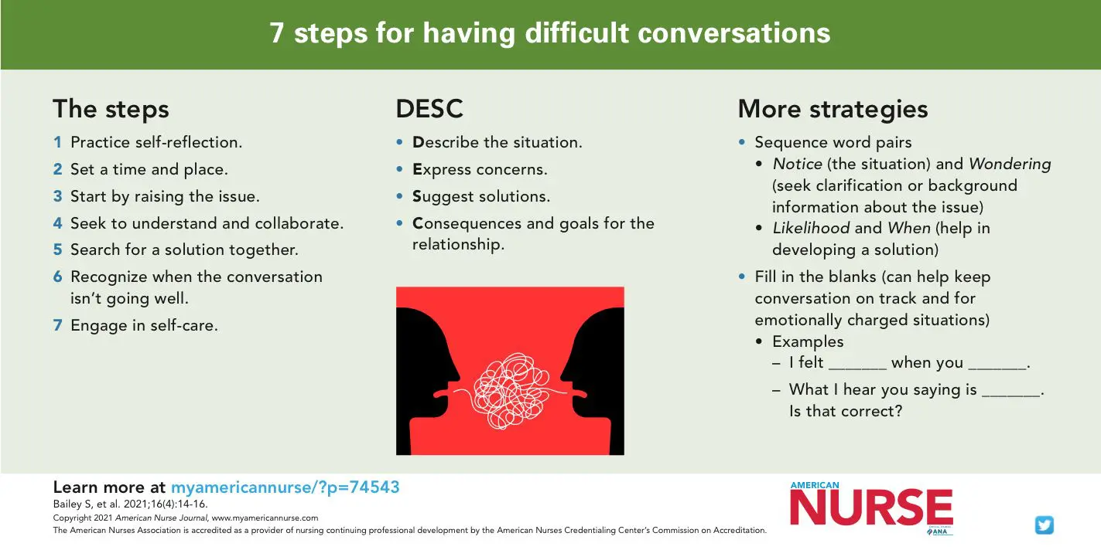
  - Make contact with the school person with whom you have a school related grievance (parents may make an appointment by phoning). It may not be possible to see you immediately – but an appointment for an appropriate time can be made. Parents are welcome to invite a Governing Council Member to support you during the process. Students are also encouraged to have a support person present. (If a primary student has a formal grievance, a family member is encouraged to attend the meeting with them.) You might like to follow this process to raise the concern.

1.2 If a resolution is not achieved in a timely manner, contact should be made with a member of the Leadership Team at the school (Principal or Coordinators) so that further follow up can take place.

1.3 If a satisfactory resolution is still not achieved contact may be made with the Education Director at the Limestone Coast Education Office.

- General issues can be raised with the Principal or Leadership Team members.

It is essential that if parents do have a school related concern or grievance, they contact the school as soon as possible so that their concern maybe resolved.

Social media is not an appropriate way to deal with a concern or grievance. If it is used for this purpose by a student, parent or community member, Department for Education processes will be followed to address this action, which may include contacting the police.

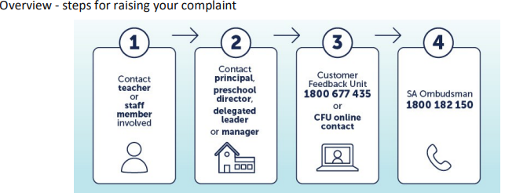
KANGAROO INN AREA SCHOOL  Policy | GRIEVANCE PROCESS  April 2025

Good relationships within the school community give children a greater chance of success. The following steps are ways through which you can raise issues or concerns regarding your child’s education.

All personal matters about student, parent or staff relationships should be made directly and confidentially with the person involved

Principles of our policy are:
- Everyone has a right to be listened to and to be treated with respect and with confidentiality maintained
- Meetings to discuss grievances will be suspended if any person(s) behaves in an insulting or offensive manner

In the event of a grievance or concern the following guidelines may be used

STUDENTS  with a grievance can | PARENTS/CARERS  with a grievance can | STAFF  with a grievance can
When you are not feeling safe  OR when you have a concern about something at school  you can take action.  - Talk to the person about the problem or write it in a letter or email.  - Talk to another adult at school about the problem at an appropriate time.  - If you feel uncomfortable, speak to someone else with whom you feel comfortable.  - If the issue is unresolved, talk to your parent(s), carer or someone you trust.  BE PERSISTENT: Don’t give up until you feel safe.  REMEMBER: it’s your responsibility to take action as we can’t help if we don’t know.  Other contacts  - Kids Helpline 1800 551 800  - Lifeline 131114  - Headspace.org.au | - Make an appointment to meet with the teacher or staff member.  - If the issue is not resolved make an appointment with the Principal / Coordinator.  - If the matter is not resolved through the school, contact the Education Director at the Limestone Coast Regional Office, phone 87245300.  Further information, including timelines, is available in the attached documents –  DFE Parent Complaints Policy and the DFE Parent Concern and Complaints Procedure.  If you require support, information or advice please contact the -  DFE Parent Complaints Unit Hotline - 1800 677 435  Parent Helpline 1300 364 100 | - Arrange a time to speak with the person concerned.  - Allow a reasonable time for the issue to be addressed.  - If the grievance is not resolved speak to the Principal or Line Manager and/or the nominated contact where appropriate  - DFE Counsellor  - WHS Rep / Counsellor  - AEU Representative  - PAC member  Ask for their support in  addressing the grievance by:  - Speaking to the person with whom you have the grievance  - Monitoring the situation  - Investigating your concern  - Acting as a mediator  If the issue is not resolved within a reasonable time arrange a time to speak with the Education Director.  Employee Assistance Program  - Corporate Health 1800 870 147  - ACCESS 1300 66 77 00  - Human Psychology 1300 277 924  - Benestar 1300 360 364

